**IDOR in Password Reset Form**

**where are the robots**

Vulnerability Description:

The creator of the challenge is the vulnerability of the challenge. The web crawlers help in finding the creator. So, the web crawler is the vulnerability.

Summary:

The hint of the task specifies that finding the creator of the challenge will get us to the flag. And the challenge askes “Where is the robots?”. So, there is a relation between the robots in this challenge. Adding robots.txt in the URL of the challenge gives the URL that will allow us to reach the flag. Replacing the disallow URL instead of robots.txt , we get the flag.

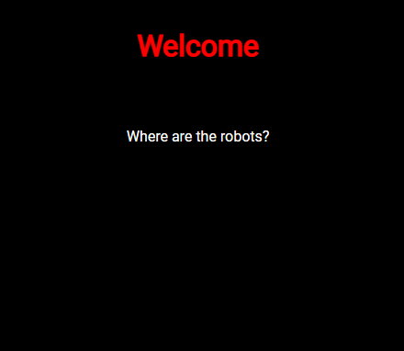

This is the given webpage.

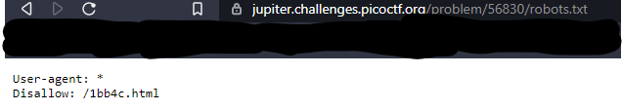

Changing the URL with robots.txt

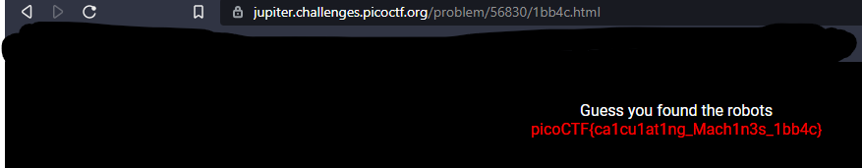

Replacing the disallow URL with robots.txt ,we get the flag.

So, the flag is: picoCTF{ca1cu1at1ng_Mach1n3s_1bb4c}